GRANARD MUNICIPAL DISTRICT

Corporate Affairs,
Please note time and Aras an Chontae,
venue of meetings. LONGFOIRT.

16th November 2016.

To: Each Member of Granard Municipal District.

Dear Member,

You are requested to attend the following Meetings of Granard Municipal District to be held in the Thomas Ashe Memorial Hall, Ballinalee on Tuesday, 22nd November 2016 -

2.30 p.m. - Committee Meeting to consider allocation of funding from the General Municipal Allocation.

3.30 p.m - November Municipal District Meeting - Agenda hereunder

Please park in area across from the Hall.

Yours sincerely,
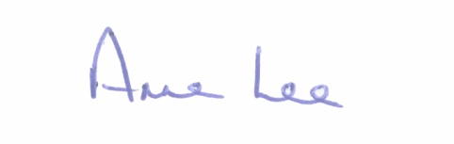

_______________
Anne Lee,
Meetings Administrator.

AGENDA

Prayer before meeting.

1. Confirmation of Minutes of the Municipal District meetings held on the
27th September and 25th October 2016 - copy enclosed.

2. Matters arising from Minutes.

3. Presentation by Lus na Greine Family Resource Centre.

4. Area Engineer’s Progress Report.

5. Update on the Provision of pedestrian crossing in Ballinalee.

6. Provision of CCTV in the Granard Municipal District area.

7. Consideration of funding for new footpaths.

8. Notices of Motions submitted by Councillors, as listed hereunder –

Councillor Michael Carrigy.

“I call on Longford County Council to carry out road safety works at Scoil Samhthann, Ballinalee.”

“I call on Longford County Council to apply for a Low Cost Safety Scheme at Ballymacwilliam, Longford.”

“I call on Irish Water to replace the old mains pipework at Cloncoose Longford and add 1km section to the planned replacement works from the reservoir at Smear Aughnacliffe .”

Councillor Paraic Brady.

“Consideration of Safety Schme at Knockloughlin.”

Councillor Luie McEntire.

“That this Council changes the broken line to continuous white line at Lennons Turn on main Drumlish/Arva road, for safety reasons.”

9. Correspondence – attached.

- Letter received from Local Government Development Section, Department of Housing, Planning, Community & Local Government regarding the dissolution of the Lough Oughter and Gowna and the River Erne Drainage Committees.

10. A.O.B.

